

Semester One Examination, 2019

Question/Answer booklet

MATHEMATICS

SOLUTIONS
METHODS
UNIT 1

Section Two:

Calculator-assumed

Student number: In figures

In words

Your name

Time allowed for this section
Reading time before commencing work: ten minutes
Working time: one hundred minutes

Materials required/recommended for this section
To be provided by the supervisor
This Question/Answer booklet
Formula sheet (retained from Section One)

To be provided by the candidate
Standard items: pens (blue/black preferred), pencils (including coloured), sharpener,
correction fluid/tape, eraser, ruler, highlighters

Special items: drawing instruments, templates, notes on two unfolded sheets of A4 paper, and up to three calculators approved for use in this examination

Important note to candidates
No other items may be taken into the examination room. It is your responsibility to ensure that you do not have any unauthorised material. If you have any unauthorised material with you, hand it to the supervisor before reading any further.

Structure of this paper

Section | Number of questions available | Number of questions to be answered | Working  time (minutes) | Marks available | Percentage of examination
Section One:  Calculator-free | 8 | 8 | 50 | 52 | 35
Section Two:  Calculator-assumed | 13 | 13 | 100 | 98 | 65
 |  |  |  | Total | 100

Instructions to candidates

1. The rules for the conduct of examinations are detailed in the school handbook. Sitting this examination implies that you agree to abide by these rules.

2. Write your answers in this Question/Answer booklet preferably using a blue/black pen.
Do not use erasable or gel pens.

3. You must be careful to confine your answer to the specific question asked and to follow any instructions that are specified to a particular question.

4. Show all your working clearly. Your working should be in sufficient detail to allow your answers to be checked readily and for marks to be awarded for reasoning. Incorrect answers given without supporting reasoning cannot be allocated any marks. For any question or part question worth more than two marks, valid working or justification is required to receive full marks. If you repeat any question, ensure that you cancel the answer you do not wish to have marked.

5. It is recommended that you do not use pencil, except in diagrams.

6. Supplementary pages for planning/continuing your answers to questions are provided at the end of this Question/Answer booklet. If you use these pages to continue an answer, indicate at the original answer where the answer is continued, i.e. give the page number.

7. The Formula sheet is not to be handed in with your Question/Answer booklet.
Section Two: Calculator-assumed 65% (98 Marks)
This section has thirteen (13) questions. Answer all questions. Write your answers in the spaces provided.

Working time: 100 minutes.

Question 9 (6 marks)
(a) The points $A$ and $B$ have coordinates $(4, -6)$ and $\left(5, 8\right)$ respectively. If $B$ is the midpoint of $A$ and $C$, determine the coordinates of $C$. (3 marks)
Solution
$$\text{If} C\left(x, y\right)\text{ then}$$

$$\frac{4+x}{2}=5⇒x=6 \text{and}\frac{-6+y}{2}=8⇒y=22$$

$$C\left(6, 22\right)$$

Specific behaviours
writes equations for midpoints
✓ $x$-coordinate of $C$
✓ $y$-coordinate of $C$

(b) The points $D$ and $E$ have coordinates $(5p, -q)$ and $\left(2q, 3p\right)$ respectively, where $p$ and $q$ are constants. Determine the value of $p$ and the value of $q$ if the midpoint of $D$ and $E$ is at $(21, 17)$. (3 marks)
Solution
$$\frac{5p+2q}{2}=21 \text{and} \frac{-q+3p}{2}=-11$$

Solve simultaneously CAS to get $p=10, q=-4$

Specific behaviours
equations for both coordinates of midpoint
✓ value of $p$
✓ value of $q$

Question 10 (8 marks)
(a) The variables $C$ and $x$ are directly proportional and when $x=5, C=60$.

(i) Determine an equation for the relationship between $C$ and $x$. (2 marks)
Solution
$$C=mx, m=\frac{60}{5}=12⇒C=12x$$

Specific behaviours
indicates use of line through origin
✓ correct relationship

(ii) State the value of $C$ when $x=15$. (1 mark)
Solution
$$C=12\left(15\right)=180$$

Specific behaviours
correct value

(b) The time, $t$ minutes, that a car takes to travel one kilometre at a constant speed of $s$ kmh⁻¹ is given by the formula $t=\begin{matrix}k \\ \overline{s}\end{matrix}$ .

(i) Determine the value of the constant $k$, given that when $s=40, t=90$. (1 mark)
Solution
$$90=\frac{k}{40}⇒k=3600$$

Specific behaviours
correct value

(ii) Determine the value of $t$ when $s=30$. (1 mark)
Solution
$$t=3600÷30=120$$

Specific behaviours
correct value

(iii) On the axes below, draw a graph to show how $s$ varies with $t$. (3 marks)
Solution
See graph. Key points:
$$\left(20, 180\right), \left(30, 120\right), \left(40, 90\right),$$
$$\left(60, 60\right),\left(90, 40\right),(120, 30)$$
Specific behaviours
plots at least 2 key points
✓ plots 4 key points
✓ smooth curve

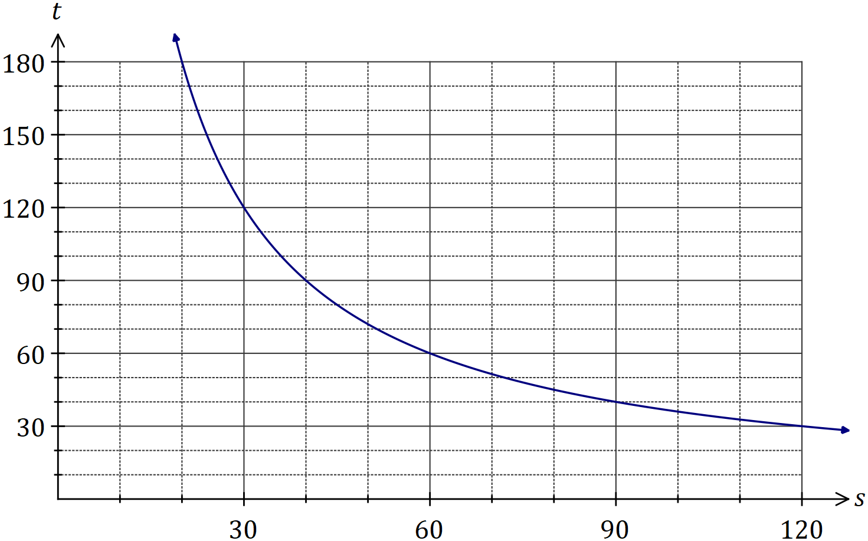

Question 11 (8 marks)

In an experiment, the sound intensity, $S$, can be modelled by $S\left(x\right)=3.6-2.4x+1.5x^{2}-0.2x^{3}$, where $x$ is the distance from the sound source in metres and $0≤x≤6$.

(a) Determine $S$ when $x=3$. (1 mark)
Solution
$$S\left(3\right)=4.5$$

Specific behaviours
correct value

(b) Draw the graph of $y=S(x)$ on the axes below. (4 marks)
Solution
See graph
Specific behaviours
intercepts
✓ accurate maximum
✓ accurate minimum
✓ smooth curve

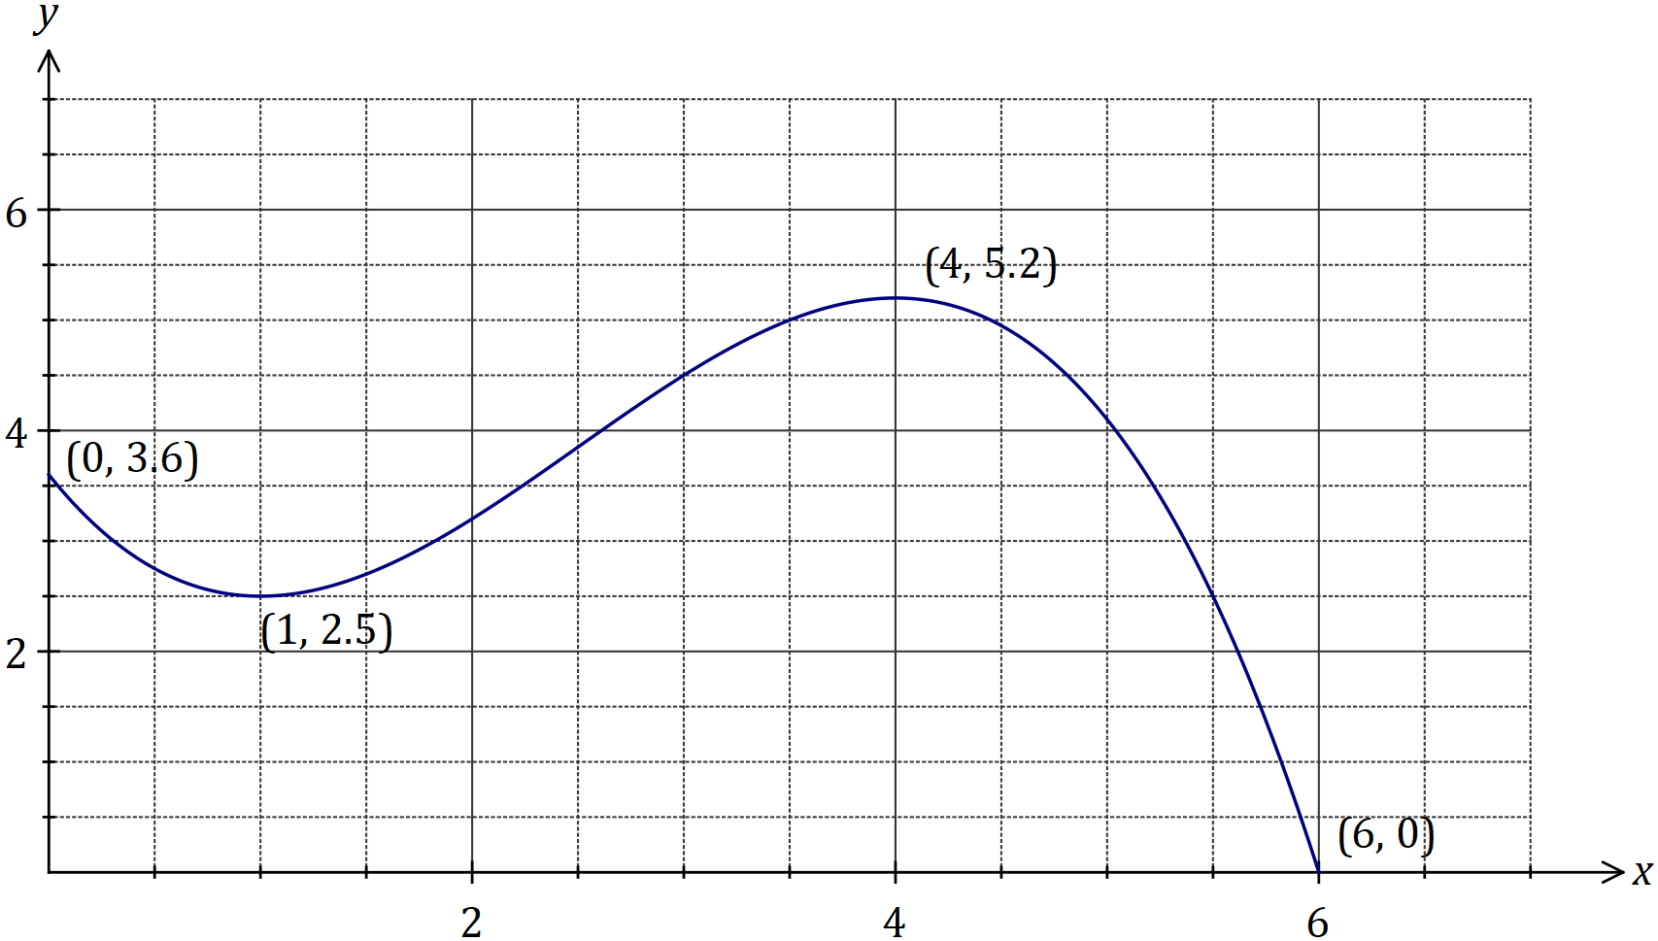

(c) Determine the equation of the straight line $L$ that passes through the $x$-intercept and the $y$-intercept of the graph of $y=S(x)$. (2 marks)
Solution
$$\left(0, 3.6\right) \& \left(6, 0\right)⇒m=-3.6÷6=-0.6$$
$$y=-0.6x+3.6$$

Specific behaviours
gradient
✓ $y$-intercept and equation

(d) Determine the coordinates of the point of intersection of $L$ with the graph of $y=S(x)$ where $x>0$ and $y>0$. (1 mark)
Solution
$$\left(1.5, 2.7\right)$$

Specific behaviours
correct coordinates

Question 12 (8 marks)
(a) A parabola with equation $y=a(x-b)(x+c)$ has turning point at $\left(2, -8\right)$ and y-intercept at $\left(0, -6\right)$. The constants $a, b$ and $c$ are all positive.

(i) Determine the values of the positive constants $a, b$ and $c$. (3 marks)
Solution
$$y=a{\left(x-2\right)}^{2}-8$$
$$-6=a{\left(-2\right)}^{2}-8⇒a=0.5$$

$$y=0.5{\left(x-2\right)}^{2}-8=0.5(x+2)(x-6)$$

$$a=0.5, b=6, c=2$$

Specific behaviours
uses TP form to deduce $a$
✓ uses CAS to obtain factored form
✓ three correct values

(ii) The parabola is translated $10$ units to the left and $5$ units downwards. Determine the equation of the transformed parabola in the form $y=a{\left(x-p\right)}^{2}+q$.
(2 marks)
Solution
$$y=0.5{\left(x-2+10\right)}^{2}-8-5 \\ =0.5{\left(x+8\right)}^{2}-13$$

Specific behaviours
writes with correct value of $p$
writes with correct value of $q$

(b) The graph of the cubic function $y=f(x)$ is shown below. Determine $f(10)$. (3 marks)

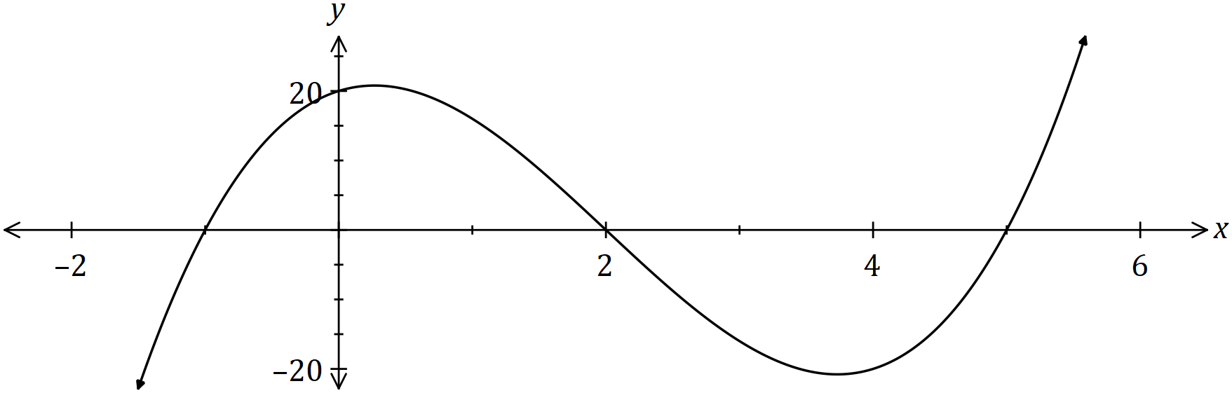
Solution
$$f\left(x\right)=a(x+1)(x-2)(x-5)$$

$$20=a\left(1\right)\left(-2\right)\left(-5\right)⇒a=2$$

$$f\left(10\right)=2\left(11\right)\left(8\right)\left(5\right)=880$$

Specific behaviours
cubic in factored form
✓ correct value of $a$
✓ required value

Question 13 (8 marks)
The graph of $y=f(x)$ is shown below where $f\left(x\right)=\begin{matrix}c \\ \overline{a-x}\end{matrix}$ .

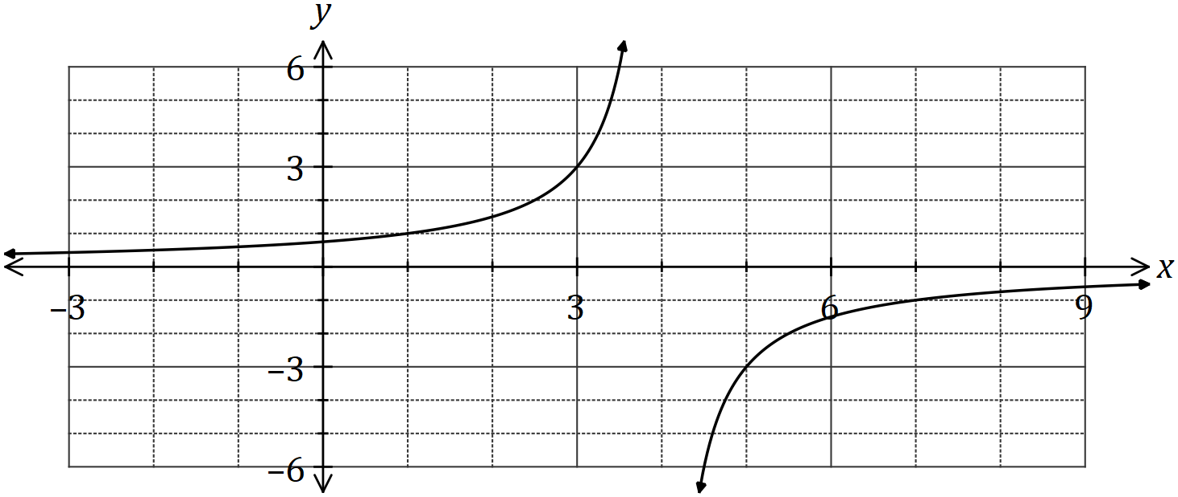

(a) State the value of the constant $a$ and the value of the constant $c$. (3 marks)
Solution
$$a=4$$

Using $\left(3, 3\right)⇒3=c÷1⇒c=3$

Specific behaviours
value of $a$
✓ uses point on curve
✓ value of $c$

(b) The hyperbola shown above has two asymptotes. State their equations. (2 marks)
Solution
$$x=4, y=0$$

Specific behaviours
vertical asymptote
✓ horizontal asymptote

(c) Describe how to transform the graph of $y=f(x)$ to obtain the graph of $y=f(x-3)$ and state the domain and range of the transformed function. (3 marks)
Solution
Translate the graph 3 unit to the right.

Domain: $x≠7$

Range: $y≠0$

Specific behaviours
transformation
✓ domain
✓ range

Question 14 (8 marks)
(a) Convert, giving an exact answer

(i) $16°$ to radians. (1 mark)
Solution
$$\frac{4π}{45}$$

Specific behaviours
✓ exact value

(ii) $0.4$ radians to degrees. (1 mark)
Solution
$$\frac{72}{π}$$

Specific behaviours
✓ exact value

(b) Calculate, to the nearest degree, the acute angle between the line $y=1.5x-4$ and the line $y=-0.5x+4$. (3 marks)
Solution
$$θ_{1}=\tan^{-1}{1.5}=56.3$$

$$θ_{2}=\tan^{-1}{-0.5}=-26.6$$

$$θ_{2}-θ_{1}=83°$$

Specific behaviours
indicates use of $\tan^{-1}{m}$
✓ one correct angle with $x$-axis
✓ correct angle between lines

(c) The sides adjacent to the right-angle in a right triangle have lengths $65$ cm and $72$ cm.

If the smallest angle in the triangle is $α$, determine an exact value for
Solution
$$\tan{α}=\frac{65}{72}$$

Specific behaviours
correct ratio

(i) $\tan{α}$. (1 mark)

(ii) $\sin{(90°-α)}$. (2 marks)
Solution
$$\sqrt{{65}^{2}+{72}^{2}}=97$$

$$\sin\left(90°-α\right)=\frac{72}{97}$$

Specific behaviours
calculates length of hypotenuse
✓ correct ratio for sine

Question 15 (7 marks)
An obtuse angled triangle $ABC$ has $a=36$ cm, $c=52$ cm and an area of $748$ cm².

(a) Sketch a triangle to show this information. (1 mark)
Solution
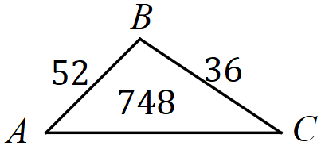

Specific behaviours
triangle with all information

(b) Determine the size of $∠B$. (2 marks)
Solution
$$748=\frac{1}{2}\left(52\right)\left(36\right)\sin{B}$$

$$B=126.95≈127°$$

Specific behaviours
substitutes into area equation
✓ correct (obtuse) angle

(c) Show that $b≈79$ cm. (2 marks)
Solution
$$b^{2}={52}^{2}+{36}^{2}-2\left(52\right)\left(36\right)\cos{126.95}$$

$$b=79.06≈79 \text{cm}$$

Specific behaviours
uses appropriate equation that includes $b$
✓ substitutes correctly and solves to at least 1 dp

(d) Show that $∠C≈32°$. (2 marks)
Solution
$$\frac{52}{\sin{C}}=\frac{79.06}{\sin{126.95}}$$

$$∠C=31.71≈32°$$

Specific behaviours
uses appropriate equation that includes $C$
✓ substitutes correctly and solves to at least 1 dp

Question 16 (8 marks)
A small weight, attached to the bottom of a spring, oscillated up and down. The distance, $d$ cm, of the weight from the top of the spring after $t$ seconds can be modelled by

$$d=45+35\sin\left(\frac{3πt}{4}\right)$$

(a) Sketch the graph on the axes below for $0≤t≤3$. (4 marks)
Solutions (a), (b)
See graph
Specific behaviours
$y$-intercept and $(3, 70)$
✓ max and min
✓ inflection pt $\sim (1.3, 45)$
✓ single smooth curve
✓ accurately locates $M$

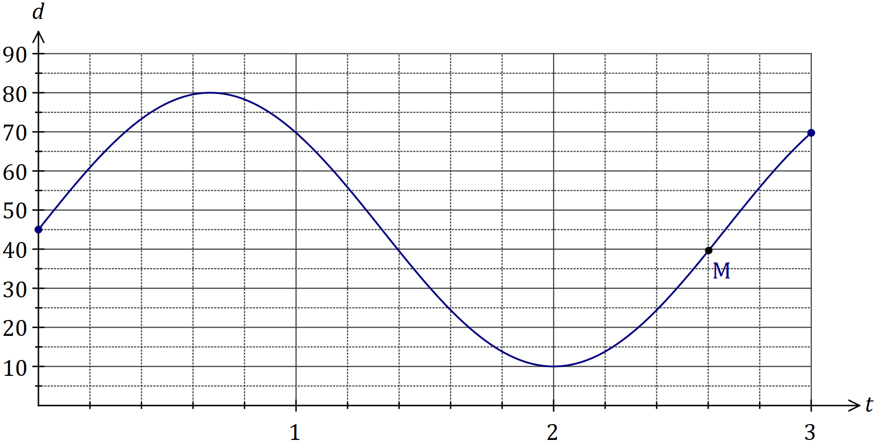

(b) Mark on your graph point $M$, where the weight is $40$ cm from the top of the spring and moving downwards. (1 mark)

(c) Determine

(i) the maximum distance of the weight from the top of the spring. (1 mark)
Solution
$$80 \text{cm}$$

Specific behaviours
correct distance

(ii) the time taken for the weight to first return to its initial position. (1 mark)
Solution
$$t=\frac{4}{3}=1.\overline{3} \text{s}$$

Specific behaviours
correct time

(iii) the distance moved by the weight between $t=1$ and $t=2$. (1 mark)
Solution
$$d\left(1\right)-d\left(2\right)=69.75-10 \\ =59.75 \text{cm}$$

Specific behaviours
correct distance

Question 17 (7 marks)
In shape $OABCD$ below, $∠AOB=126°$ and $AC$, $BD$ are diameters of the circle with centre $O$ and radius $35$ cm.
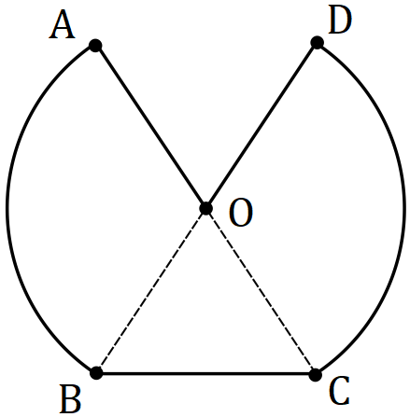

(a) Calculate the perimeter of $OABCD$. (4 marks)
Solution
$$126°=\frac{7π}{10}, π-\frac{7π}{10}=\frac{3π}{10}=54°$$

$$AB, DC:35×\frac{7π}{10}=\frac{49π}{2}≈76.97$$

$$BC^{2}={35}^{2}+{35}^{2}-2\left(35\right)\left(35\right)\cos{54} \\ BC≈31.78$$

$$P_{TOTAL}=2\left(35\right)+2\left(76.97\right)+31.78≈256 \text{cm}$$

Specific behaviours
✓ indicates length of arc $AB$
✓ indicates use of cosine rule for $BC$
✓ correct length $BC$
✓ correct total perimeter

(b) Calculate the area of $OABCD$. (3 marks)
Solution
$$AOB+DOC:2×\frac{1}{2}×{35}^{2}×\frac{7π}{10}=\frac{1715π}{2}≈2693.92$$

$$BOC:\frac{1}{2}\left(35\right)\left(35\right)\sin{54}≈496.52$$

$$A_{TOTAL}=2694.92+496.52≈3 189 {\text{cm}}^{2} (accept 3190)$$

Specific behaviours
✓ sector area $AOB$
✓ triangle area $BOC$
✓ correct total area

Question 18 (6 marks)
Let $a=\sin{50°}$ and $b=\cos{100°}$.

Give your answers to the following in terms of $a$ and/or $b$.

(a) Write down an expression for

(i) $\sin{130°}$. (1 mark)
Solution
$$\sin{130°}=\sin{50°}=a$$

Specific behaviours
correct expression

(ii) $\cos{80°}$. (1 mark)
Solution
$$\cos{80°}=-\cos{100°}=-b$$

Specific behaviours
correct expression

(b) Determine an expression for $\cos{130°}$. (3 marks)
Solution
$$\cos^{2}{130°}+\sin^{2}{130°}=1$$
$$\cos^{2}{130°}=1-a^{2}$$

$$\cos{130°}=±\sqrt{1-a^{2}}$$

$$\text{but}\cos{130°<0⇒\cos{130°}=-\sqrt{1-a^{2}}}$$

Specific behaviours
✓ indicates use of $\sin^{2}{θ}+\cos^{2}{θ}=1$
✓ expression for $\cos^{2}{130°}$
correct expression

(c) Determine an expression for $\tan{130°}$. (1 mark)
Solution
$$\tan{130°}=\frac{\sin{130°}}{\cos{130°}}=-\frac{a}{\sqrt{1-a^{2}}}$$

Specific behaviours
correct expression

Question 19 (8 marks)
(a) The equation of the axis of symmetry for the graph of $y=3x^{2}+6x+7$ is $x=k$. Determine the value of $k$.
(2 marks)
Solution
$$x=-\frac{6}{2×3}=-1$$  $$k=-1$$ | $$y=3{\left(x+1\right)}^{2}+c$$  $$∴k=-1$$ | Turning point is at (-1,4)  $$∴k=-1$$
Specific behaviours
uses $x=\frac{-b}{2a}$  ✓ value of $k$ | partially completes the square   ✓ value of $k$ | identifies turning point  ✓ value of $k$

(b) A parabola with equation $y=ax^{2}+bx+c$ has a turning point at $(6, -5)$ and passes through the point $(-2, -37)$. Determine the value of $a$, the value of $b$ and the value of $c$.
(3 marks)
Solution
$$y=a{\left(x-6\right)}^{2}-5$$

$$-37=a{\left(-2-6\right)}^{2}-5⇒a=-0.5$$

$$y=-0.5{\left(x-6\right)}^{2}-5$$
$$=-0.5x^{2}+6x-23$$

$$a=-0.5, b=6, c=-23$$

Specific behaviours
correctly writes in turning point form
✓ solves for $a$ using point
✓ expands and states all values

(c) Determine the value of the discriminant for the quadratic equation $16x^{2}-24x+9=0$ and use it to state how many solutions the equation $\left(x+1\right)\left(16x^{2}-24x+9\right)=0$ will have.
(3 marks)
Solution
$$d={(-24)}^{2}-4\left(16\right)\left(9\right)=0$$

When $d=0$, quadratic will have one solution.

Hence equation will have two solutions - one from linear factor and one from quadratic factor.

Specific behaviours
value of discriminant
✓ uses discriminant to say quadratic will have one solution
✓ states that cubic equation has two solutions

Question 20 (8 marks)
(a) Show, using one or more identities from the formula sheet and without using the value of any trigonometric term, that (3 marks)

$$\cos{40°}\cos{10°}-\sin{40°}\sin{10°}=\sin{140°}$$
Solution
$$\cos{40°}\cos{10°}-\sin{40°}\sin{10°}=\cos\left(40°+10°\right) \\ =\cos{50°} \\ =\sin\left(90°+50°\right) \\ =\sin{140°}$$

Specific behaviours
shows uses of sum identity
✓ reduces LHS to $\cos{50°}$
✓ shows use of phase shift to obtain result

(b) Simplify $\sin{A}\cos{(A-B)}-\cos{A}\sin{(A-B)}$. (2 marks)
Solution
$$\sin{A}\cos\left(A-B\right)-\cos{A}\sin\left(A-B\right)=\sin\left(A-\left(A-B\right)\right) \\ =\sin{B}$$

Specific behaviours
indicates use of difference identity
✓ correct result

(c) The graph of $y=f(x)$ is shown below, where $f(x)=\sin{(x+c)}$ and $c$ is a constant.

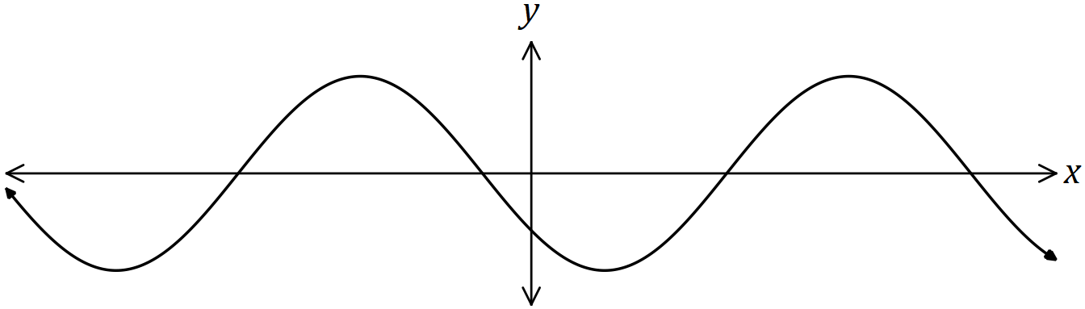

Explain how to obtain the graph of each function below from the graph of $f(x)$, given that $a$ and $b$ are also constants.

(i) $y=\sin{(x+a)}$. (2 marks)
Solution
Translate graph horizontally by $(c-a)$ units

Specific behaviours
✓ uses horizontal translation
✓ correct expression for distance

(ii) $y=\cos{(x+b)}$. (1 mark)
Solution
Translate graph horizontally by $\left(c-b-\frac{π}{2}\right)$ units

Specific behaviours
✓ correct explanation

Question 21 (8 marks)
(a) The circle shown has centre $O$ and diameter $AC$ of length $50$ cm. Determine the shaded area given that $2×∠AOB=3×∠BOC$. (4 marks)

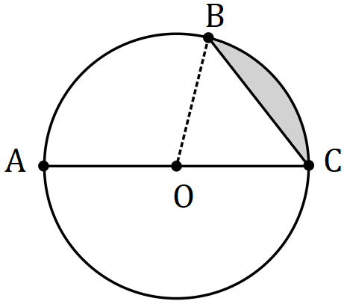
Solution
$$∠AOB=\frac{3}{2}∠BOC$$

$$∠BOC+\frac{3}{2}∠BOC=π⇒ ∠BOC=\frac{2π}{5}=72°$$

$$A=\frac{1}{2}{\left(25\right)}^{2}\left(\frac{2π}{5}-\sin{\frac{2π}{5}}\right) \\ =95.5 {\text{cm}}^{2}$$

Specific behaviours
equation using angles
✓ correct angle for segment
✓ substitutes correctly into formula
✓ correct area

(b) A sector of a circle has a perimeter of $112$ cm and an area of $735$ cm². Determine the radius of the circle. (4 marks)
Solution
$$2r+rθ=112$$

$$\frac{1}{2}r^{2}θ=735$$

Solving simultaneously gives

$$r=21, θ=\frac{10}{3} \text{or} r=35, θ=\frac{6}{5}$$

Hence $r=21 \text{or} r=35 \text{cm}$

Specific behaviours
equation for perimeter
✓ equation for area
✓ states one value of $r$
✓ states both values of $r$

Supplementary page

Question number: _________

Supplementary page

Question number: _________

Supplementary page

Question number: _________

Supplementary page

Question number: _________

© 2019 WA Exam Papers. Kennedy Baptist College has a non-exclusive licence to copy and communicate this document for non-commercial, educational use within the school. No other copying, communication or use is permitted without the express written permission of WA Exam Papers. SN245-132-8.

